

NAME: Rojal Pradhan

UNID: 17425095

Github link: <https://darkside005.github.io/csy1018assignment/>

Contents

Introduction ………………………………………………………………………………………………………………………………………....1

Designs…………………………………………………………………………………………………………………………………………………….1

Sketches……………………………………………………………………………………………………………………………………………….1

Sketch of Homepage…………………………………………………………………………………………………………………….1

Sketch of About……………………………………………………………………………………………………………………………1

Sketch of CV…………………………………………………………………………………………………………………………………2

Sketch of Contact…………………………………………………………………………………………………………………………3

Prototypes…………………………………………………………………………………………………………………………………………….4

Style Tile……………………………………………………………………………………………………………………………………. 4

Images I have created………………………………………………………………………………………………………………… 4

Evidence of how I have used Models of Good practice……………………………………………………………………………4

Page load speed………………………………………………………………………………………………………………………….4

Visual appearance……………………………………………………………………………………………………………………….5

Navigation………………………………………………………………………………………………………………………………….5

Progression of website over 12 weeks……………………………………………………………………………………………………6

Week 1-4…………………………………………………………………………………………………………………………………….6

Week 4-8…………………………………………………………………………………………………………………………………….7

Week 8-12………………………………………………………………………………………………………………………………….8

Validation check ……………………………………………………………………………………………………………………………………9

HTML………………………………………………………………………………………………………………………………………….9

CSS……………………………………………………………………………………………………………………………………………….9

Images of mobile view……………………………………………………………………………………………………………………………10

Conclusion……………………………………………………………………………………………………………………………………………….11

The Beginning

Before starting to create my own website I took advise of many people like my teachers, friends and family. I also got the idea from the templates available in the internet. I was a bit of confused how to start so I looked at the example given in the NILE. I have seen that people have different programming languages while making their webpage but we were restricted to use only pure CSS and HTML. After looking so many examples I finally got inspired to start the website. I decided to make a simple looking website with the pure CSS and HTML. I want to show my creativity on my website and tell the people about me. The website which inspired me were as follows:

1. <http://kellyedmunds.co.uk/>
2. <http://joel.sh/>

Designs

Sketches

The sketch of my homepage

I want my homepage user friendly so that people find easier to use. I also want my home to be attractive and simple. I will first create my logo and added in the top left corner of my webpage. I thought to keep my navigation on the top right side of webpage so that people can easily navigate on my webpage. I have thought to keep a background image on the header part to look attractive. By using navigation people can go to Home, About, CV and contact. The navigation can be black in color but I thought to change that color while hover on it. I have thought to keep some images and give some description. If people are interested on the description given there they can click to read more which will load new page. I will have a footer in the bottom which will have a connect with social media service, copyright and my name.

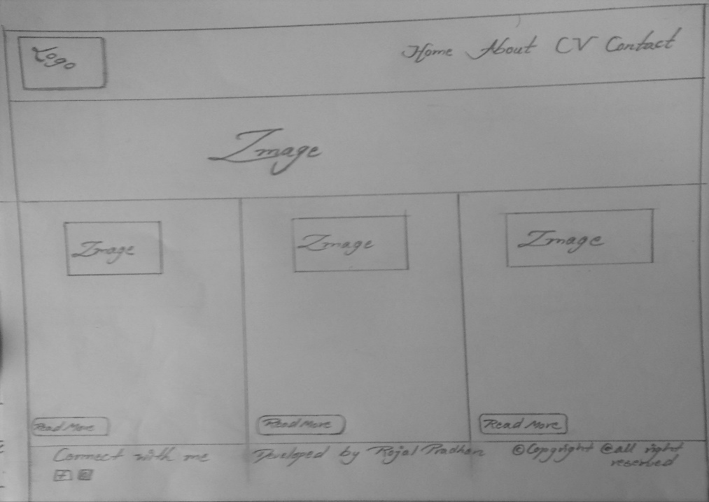

The sketch of About

I think that I have the same header part as it was in the homepage with the same navigation function. The only thing that will change is the section part with the image having some animation and the biography of my life. I thing I will also keep some of my pics. It will also have the same footer part.

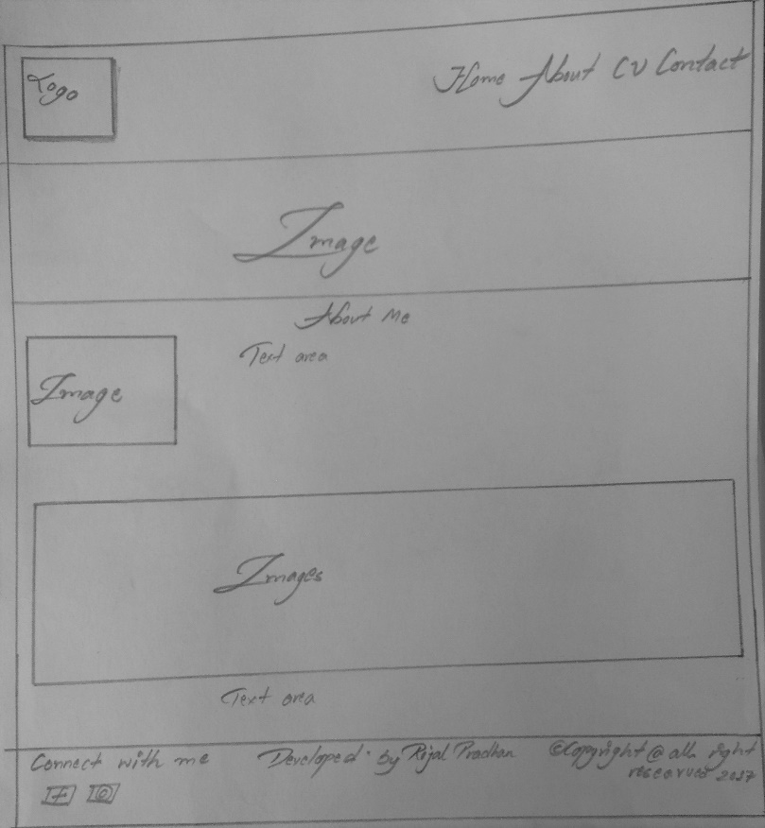

The sketch of CV

The CV includes the skills I have in the IT fields and also my other skills. It will have the same header and footer part. I want to keep my cv simple so that people won’t find hard to read it. I don’t want a messed up section part which can irritate the viewers.

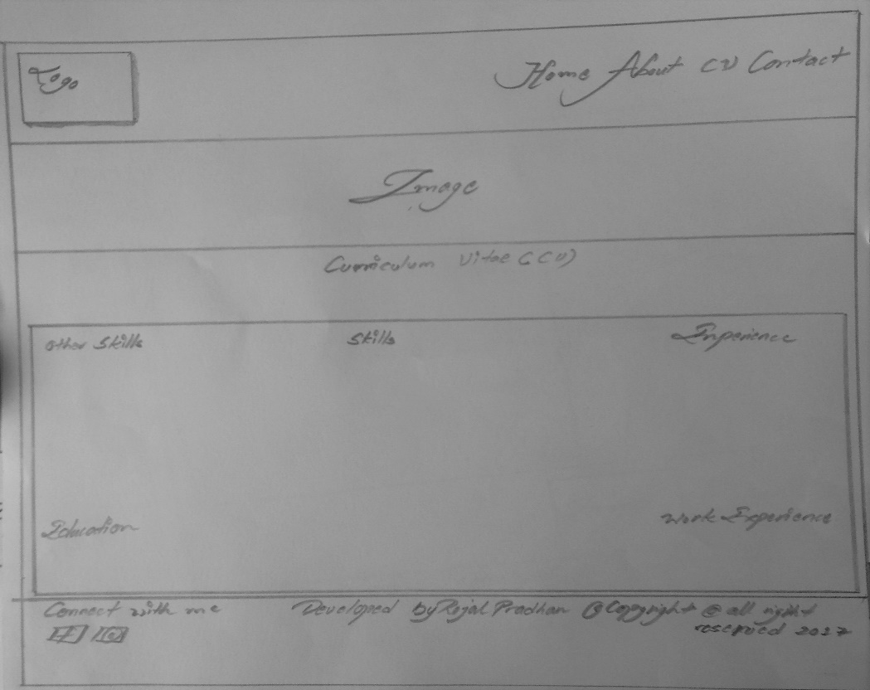

The sketch of Contact

The Contact have the input system where people can put their details and give some feedback to me. They also can contact with me or give suggestion for my webpage or on some other things. I thing I will put some images to look more attractive for the webpage.

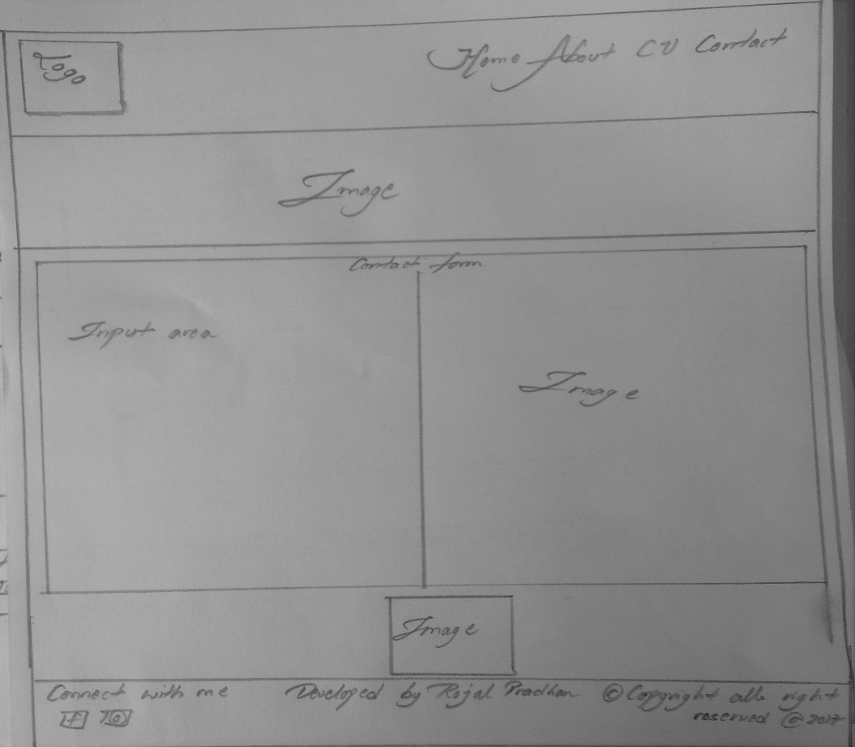

Prototype

Style Tile

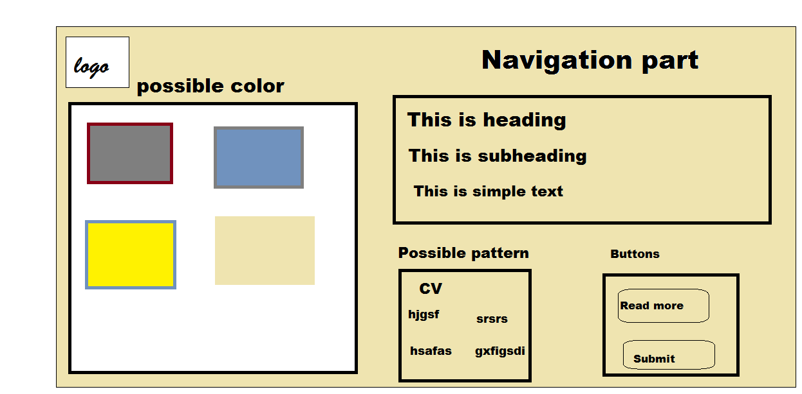

Images I have created

This is the logo of my webpage which can be seen in the top left corner of all page. I have created this logo from the Photoshop. I have to take care of the quality so that it won’t get blur which can hamper the style of a webpage. I have to clear and should be in a proper quality so that it can show as a logo of the webpage. This logo DS – is the initial of my nickname.

Evidence of how I have used Models of Good practice

Page load speed

Webpage is better when it loads faster and quicker. Every web developer should think about the page and its load time. More faster the page loads more beneficial it is for the viewers and web developer. I have tested my website on pingdom.com and the results are as follows. My webpage load speed is 381ms and faster than 98% of other tested sites. This result can be more good with low quality images which can decrease the load time.

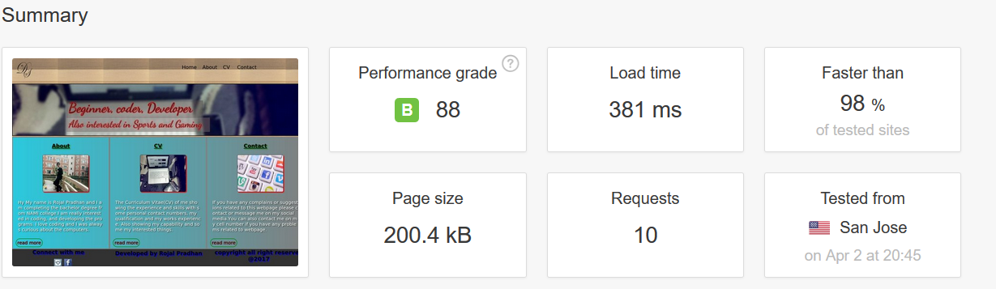

Visual Appeal

The webpage should be more creativity and attractive with the nice color combination. The webpage should be simple and able to keep the point of view more directly. The visual of webpage should be normal and attractive not by using some crazy color and design. After looking many sample websites, I have known that the color should be attractive which shines the visual of a webpage. I have tried to get the feedback from my family and friends about the visual of my webpage so that it looks more attractive.

Navigation

While making a webpage the most important thing is navigation system because people can only navigate to your webpage by the help of this system. Navigation system is one of the most important part of a webpage so it should be complicated or should be too colorful to distract the viewers. It should be kept simple and clear so that it can used perfectly and easily. I have kept navigation on the top right corner of webpage which is visible to all the viewers.

Progression of website over 12 weeks

Week 1-4



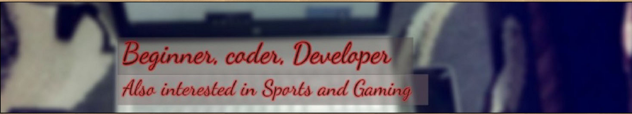

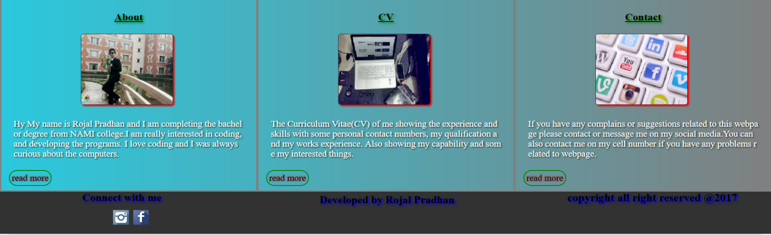

At the beginning I did some research on the internet looked more than couple of sample websites which gave me some idea to think how should my website should be mine. From week 1-4 I focused on creating the homepage and try to make it a perfect one. I set up the logo and the navigation on the top part so that is visible to all the people/viewers. In the middle part I described about some of my works, about me and the contact details. I have put a read more button so that if they are interested on knowing some more information they don’t have to search for navigation as they can be directly navigated to the respective page they click the button. The bottom part has some link which are connected directly to my social media. It also has my name described and the copyright part. The navigation and logo are same on all the other pages. I have given the uppermost part some background images and the middle part have the linear gradient color.

Week 4-8

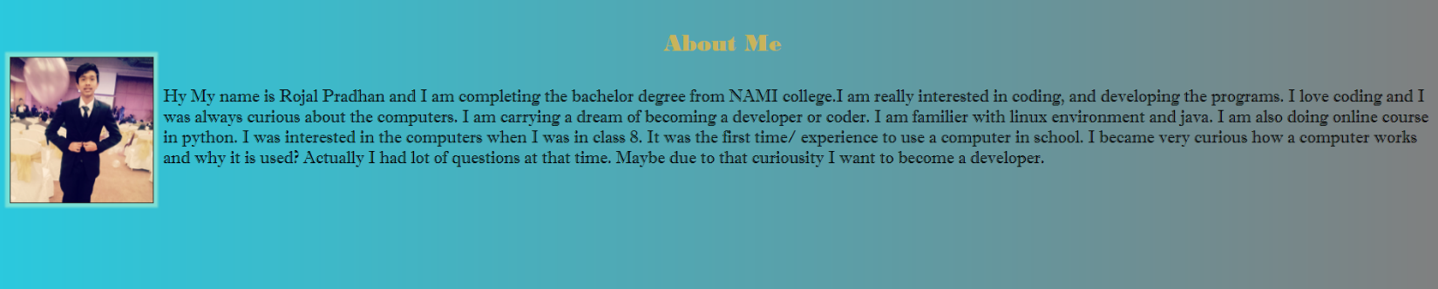

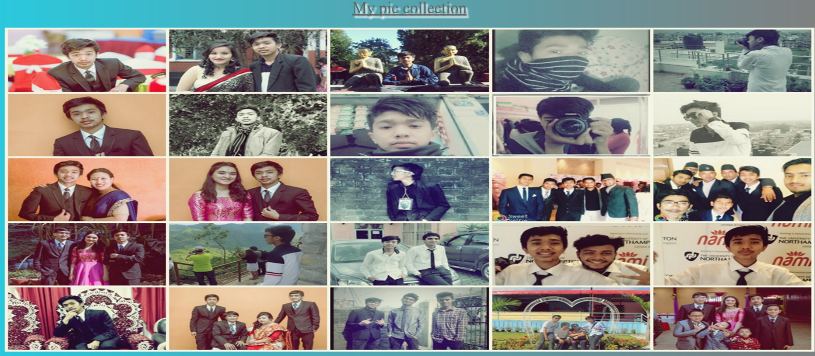

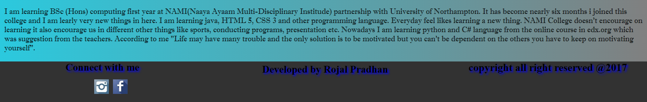

After getting all the ideas and imagining how my webpage should be I created my about and cv in 4 to 8-week time. I have put some animation on the images and some text shadow. The header and footer part was all the same. It was my about page or let’s say my bio page so I try to briefly describe about my life and I also have a displayed some images which were some special memories. I thought to keep my webpage as simple as I could and let the words describe my point of view more correctly. The CV describe about my interest so I kept it more simple with simple font so that people can know my interest and my experience. The CV simple describe about my knowledge and the works I did in the past. I didn’t thought to keep any images in my cv. I thought keeping a lot of images can increase the load time of my website. The CV I created is given as follows:

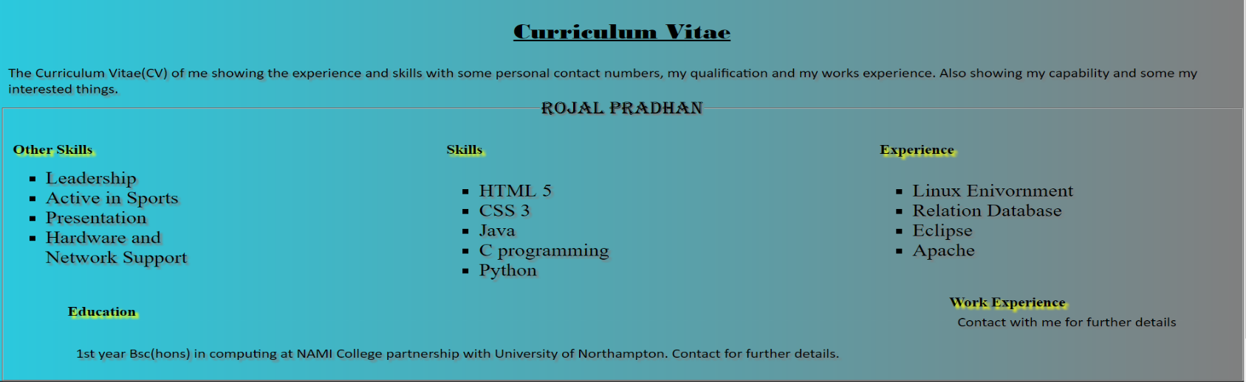

Week 8-12

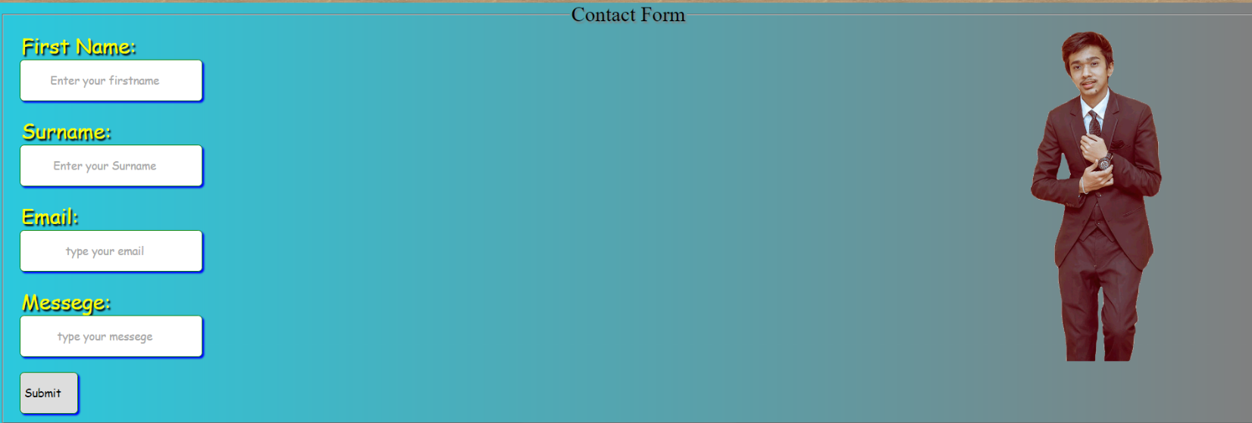

As the time of submission was coming close I thought to create my contact page. Contact page is important because people can give us the review or some opportunities. They have to put their details in the box which will direct the message to my mail due to which I can get the question/suggestion of the viewers. They can’t leave any box empty or else it will show error in their screen. The background color of the contact form is linear gradient. After the contact page is finally made I have completed my website.

Validation

HTML

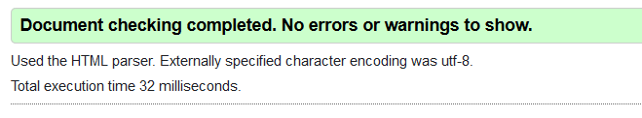

The validation checks of my html from the w3school validation.( <https://validator.w3.org/>) showing no errors or warnings.

CSS

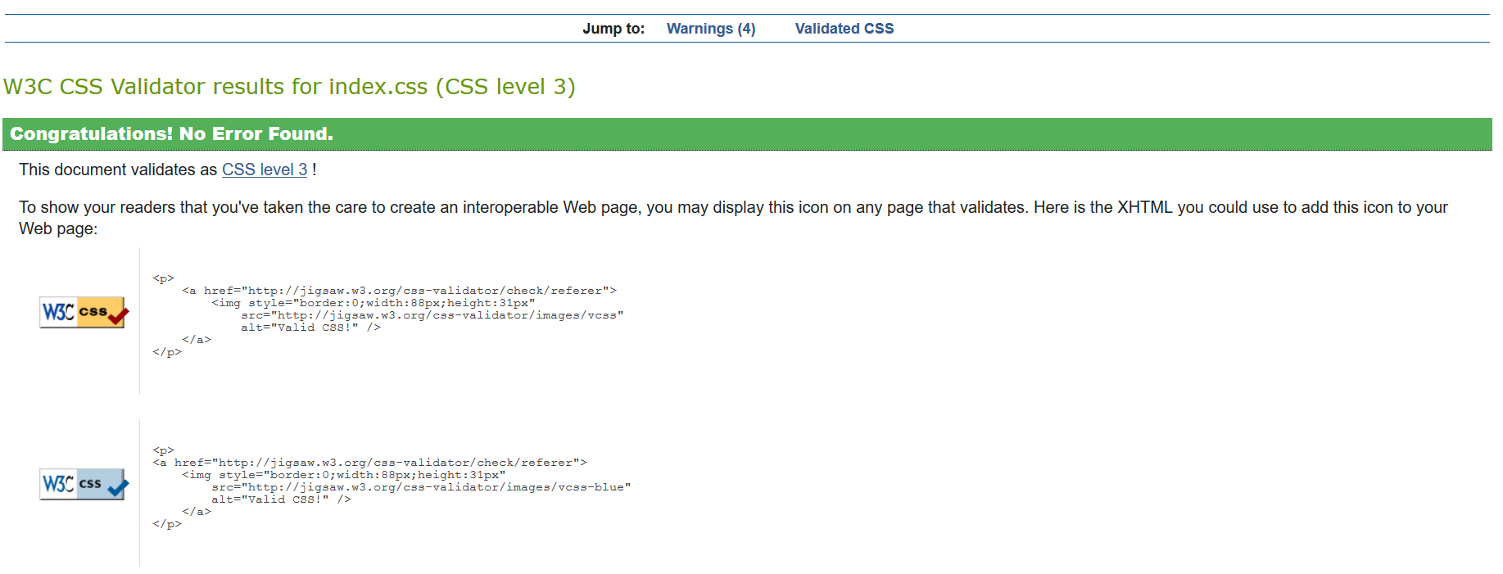

The validation check of my css from the w3 school validation (<https://jigsaw.w3.org/css-validator/#validate_by_upload>) showing no errors.

Images of mobile view

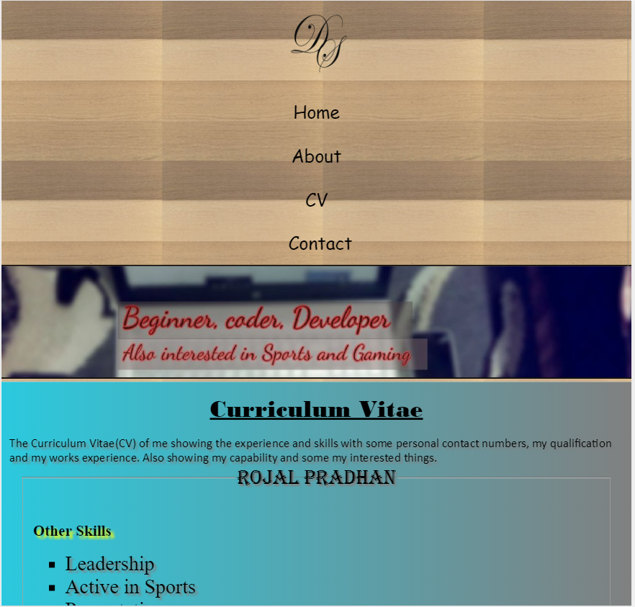

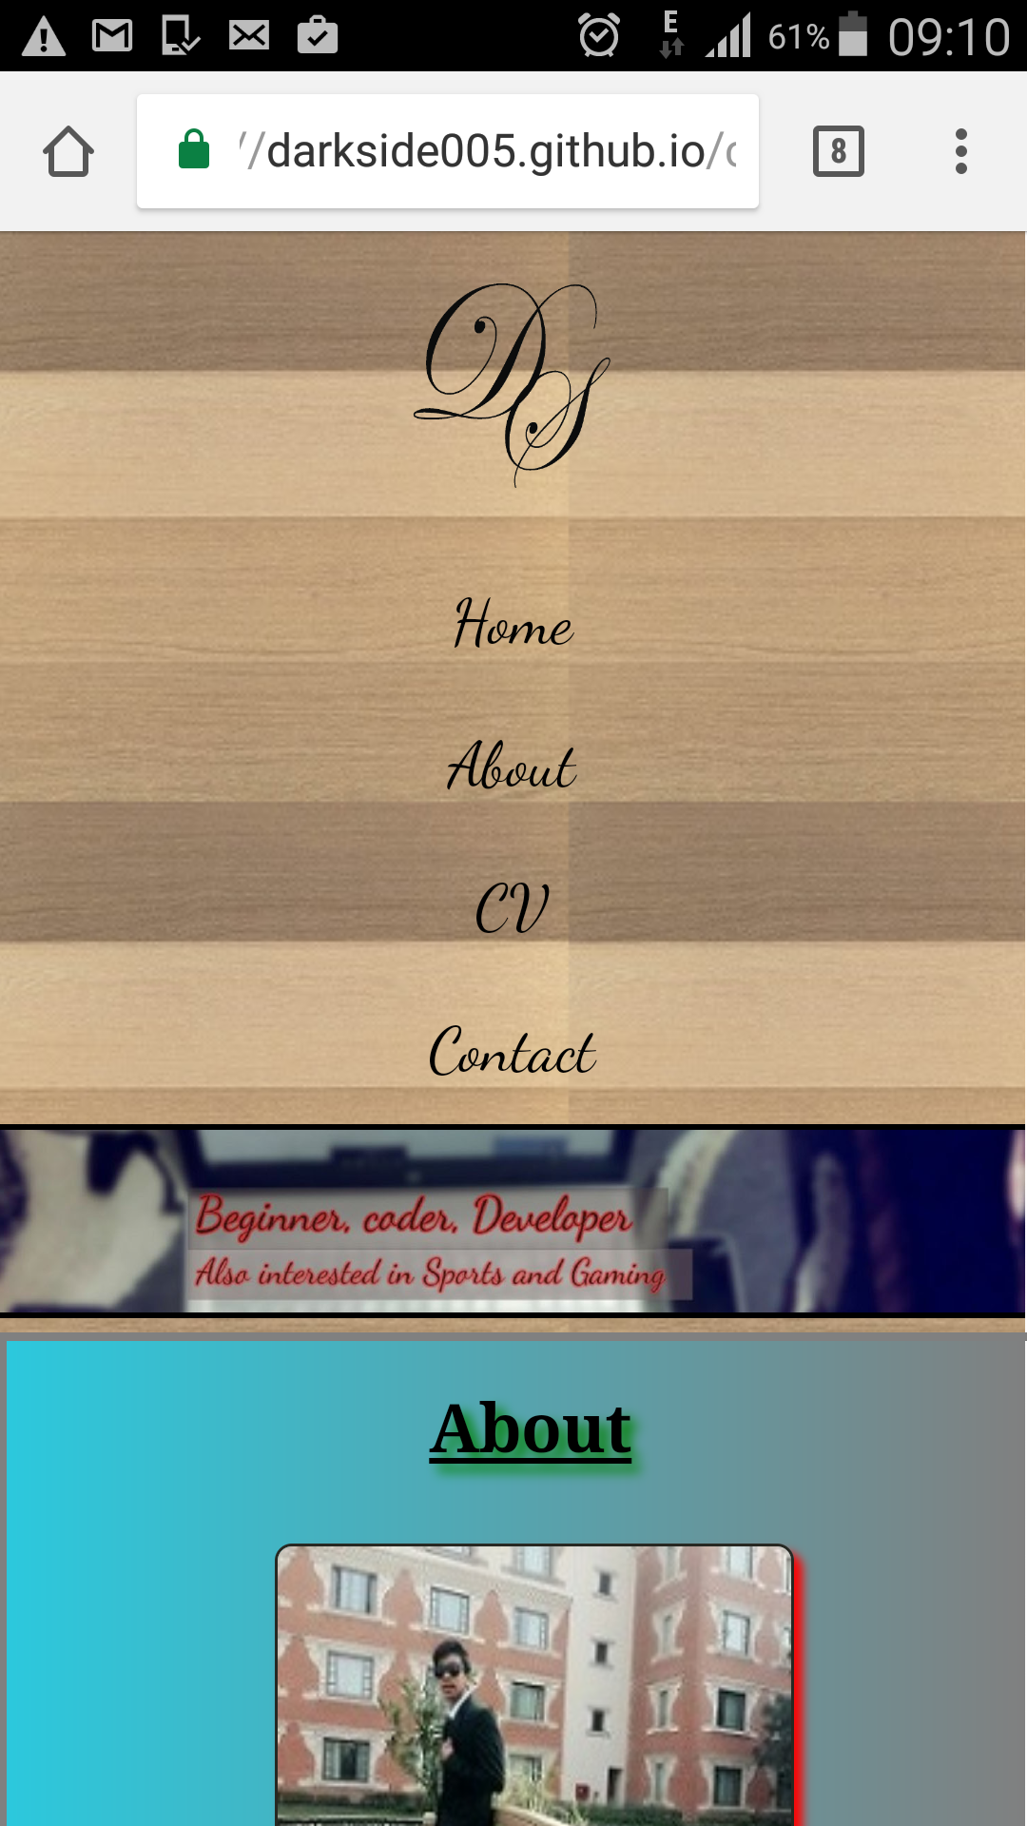

Conclusion

After the completion of my personal website I have known that there are some similarities or something that must be compulsory in webpage which are as follows

* Navigation system
* Responsive view
* Connect to social media

I have added this system and also other system which created my website to be more simple and easier to use. I have got some review from my family and teacher due to which I was able to edit and finalize my website. After completion of the website I have been familiar to many ideas. At first I was unknown to the html and css but due to the completion of this website I am very happy of my work and It also increased my knowledge in web development.